Your Gift, Their Future.
Every kwacha you give helps a child access education and empowers a widow to rebuild her life with dignity, hope, and independence.
Here is exactly what your support could do:

K750 / $40 - School Supplies for one Child
Could provide essential school supplies including books, uniform, shoes, and a school bag; giving a child the chance to learn with confidence.

K1500 / $80 - Business Starter Kit
Could empower a widow with the tools, resources, and basic training needed to start a small, sustainable business.

K1000 / $50 - Skills Training Support
Could support widows’ meetings within the community, where women receive skills training, encouragement, and practical support to rebuild their lives and support their families.

- Can we have the friends appear on the top bar so when someone clicks on Friends it still tell them about it and they can join the community by donating. Example
- When someone is using a phone who prefer having dark mode the website is completely dark is there a way we could improve this?
- Who We Serve is still not Visible? Refer to the screenshoot
- Can we make the logo more visible?
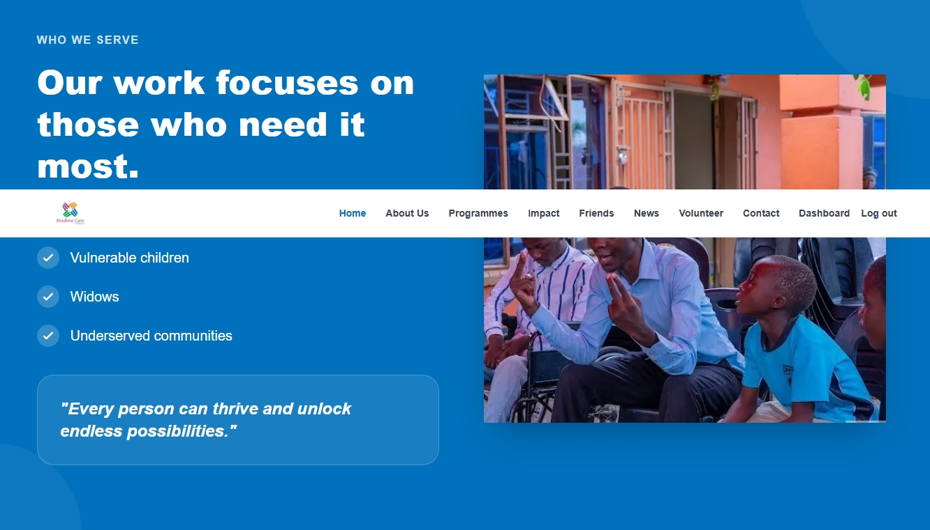


On this Page the Partner with us is taking us to volunteer page

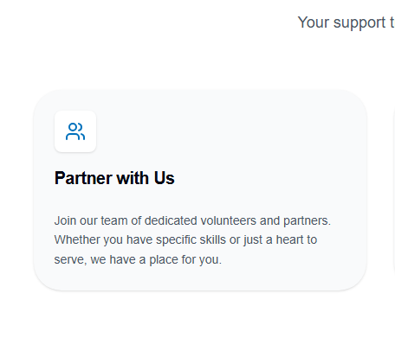
Rename this to Volunteer with us

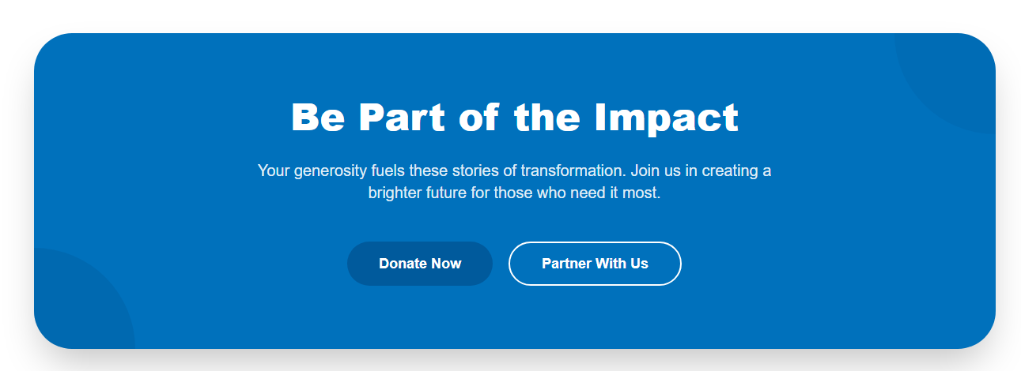
Lets get rid of this not looking good on home page

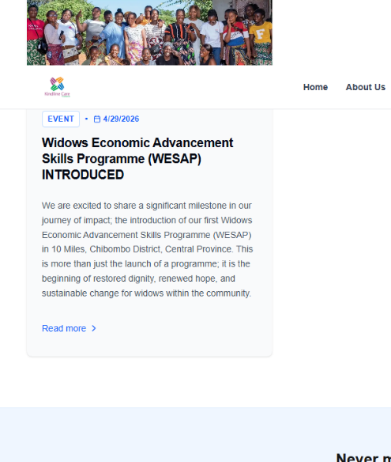
When you click on more it taking us to a page not found

